**Dashboard in Power BI**

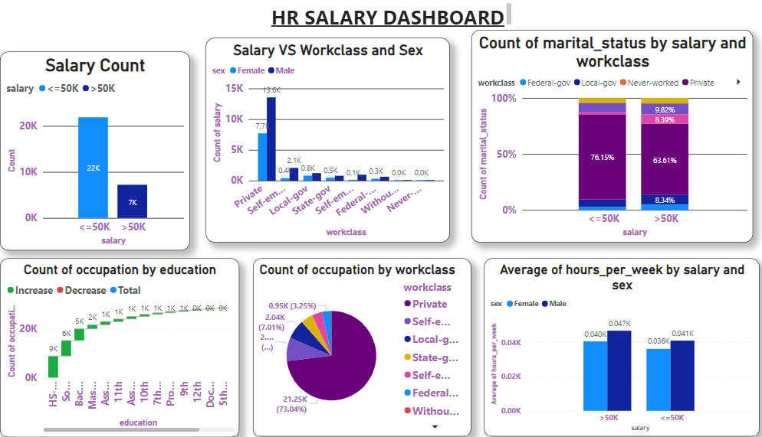

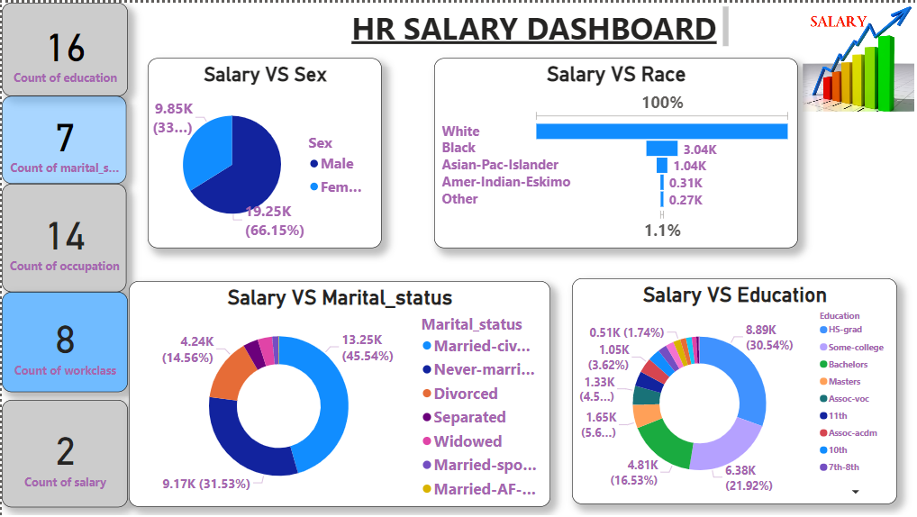

**HR Salary Predictions Dashboard**

* ***Salary Prediction Dashboard***

Link is generated http://127.0.0.1:5000/ in our web browser, and the webpage of Salary Prediction Dashboard will appear.

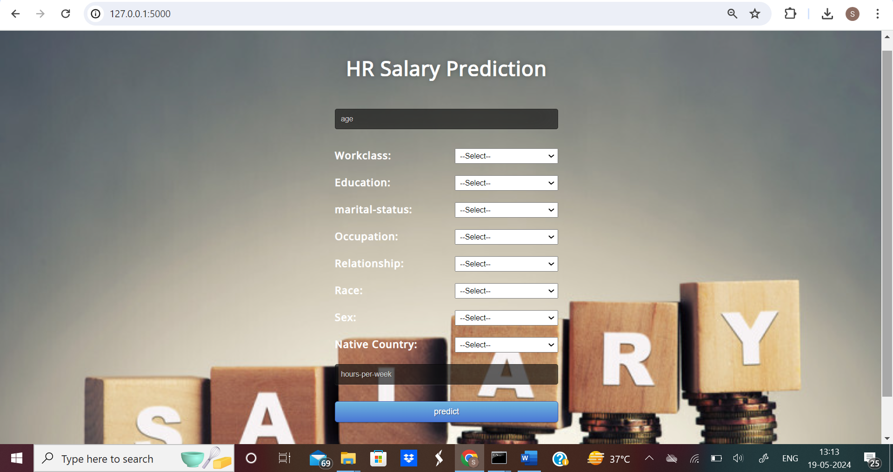

* ***Salary Dashboard Index***

Here We fill the necessary details as such: Age, work class, education, Status, Occupation, Relationship, Race, Sex, Native country and hours per week, and click on the predict Button.

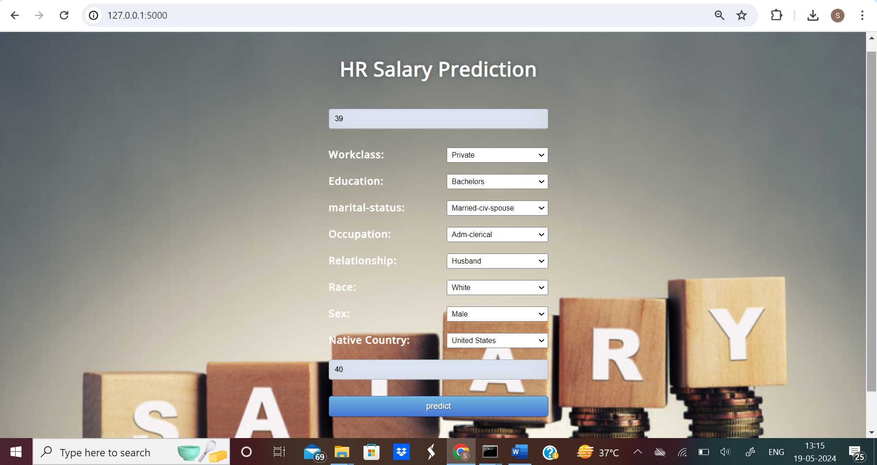

* 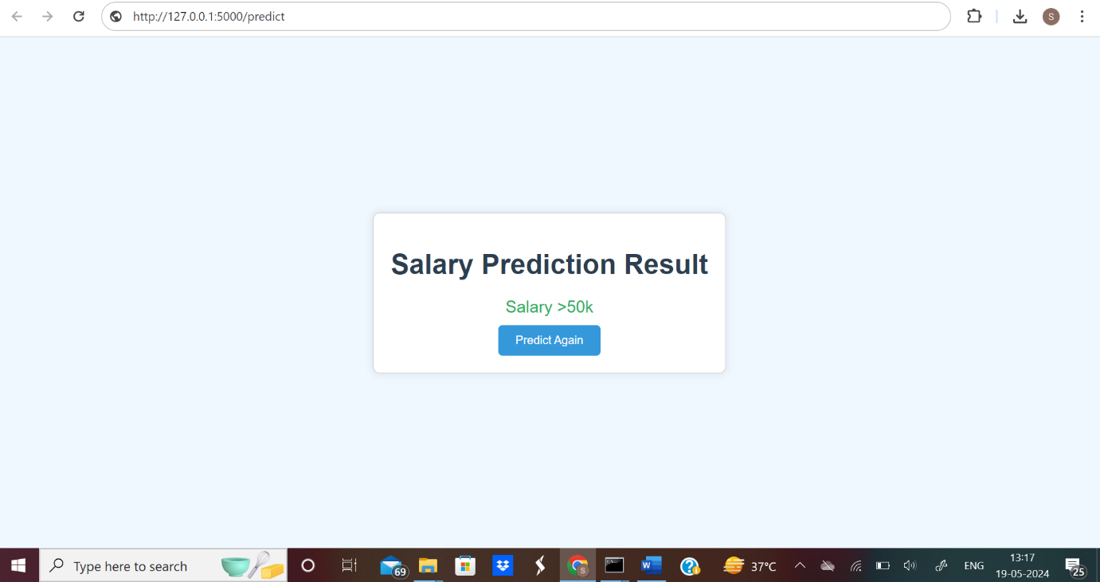***Salary Prediction Result***

Here our salary get predicted***.***